Estimation of Business Expenses

Introduction

Overview:

Estimating business expenses is an important step in determining how much money you need to start and keep your business running without encountering cash flow problems. Every business has different requirements, depending on the type of products or services it sells, the size of the company, and the stage of growth of the business. Even so, most business expenses are either one-time costs or ongoing expenses required to keep operations going.

Purpose:

An expense is a cost that businesses +

incur in running their operations. Expenses include wages, salaries, maintenance, rent, and depreciation. Expenses are deducted from revenue to arrive at profits. Businesses are allowed to deduct certain expenses from taxes to help alleviate the tax burden and bulk up profits.

Problem Definition & Design Thinking

# Empathy Map:

# 

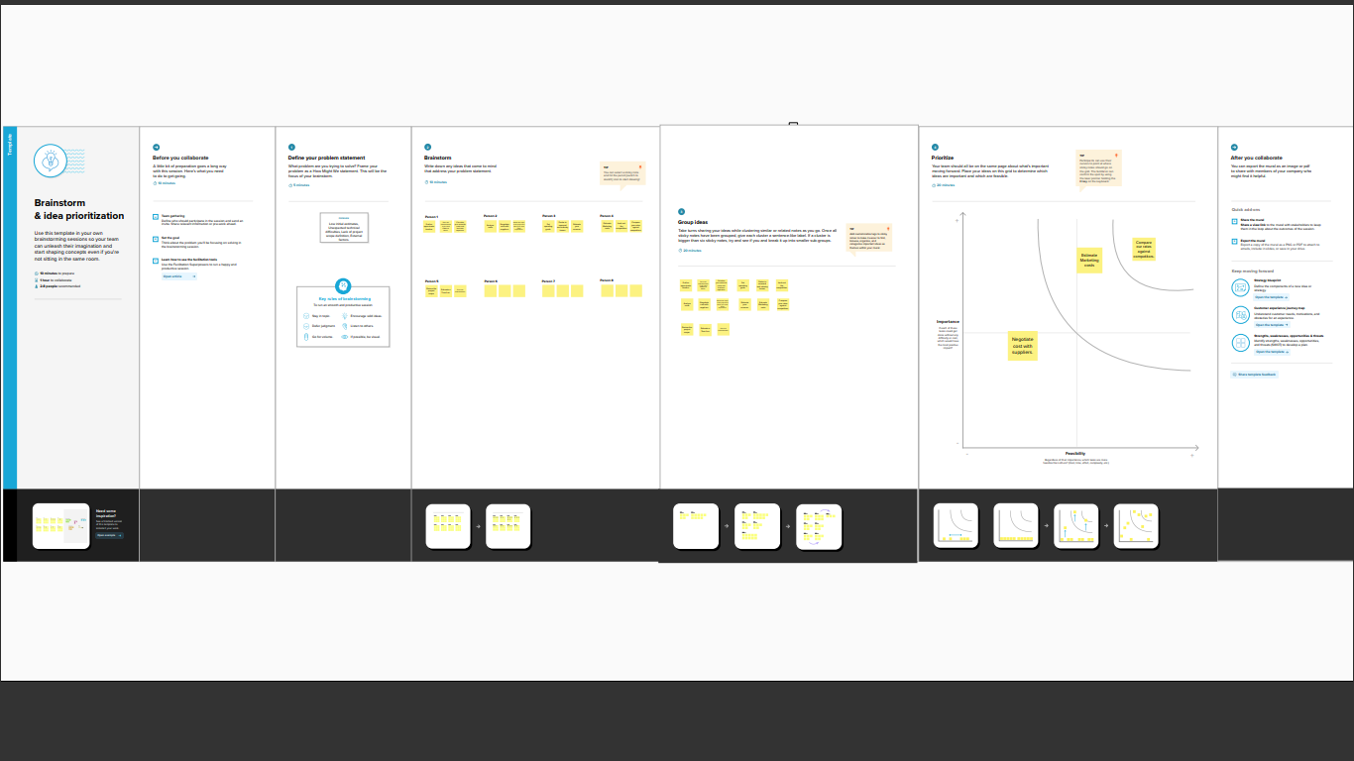Brainstorming Map:

Result:

Dashboard 1

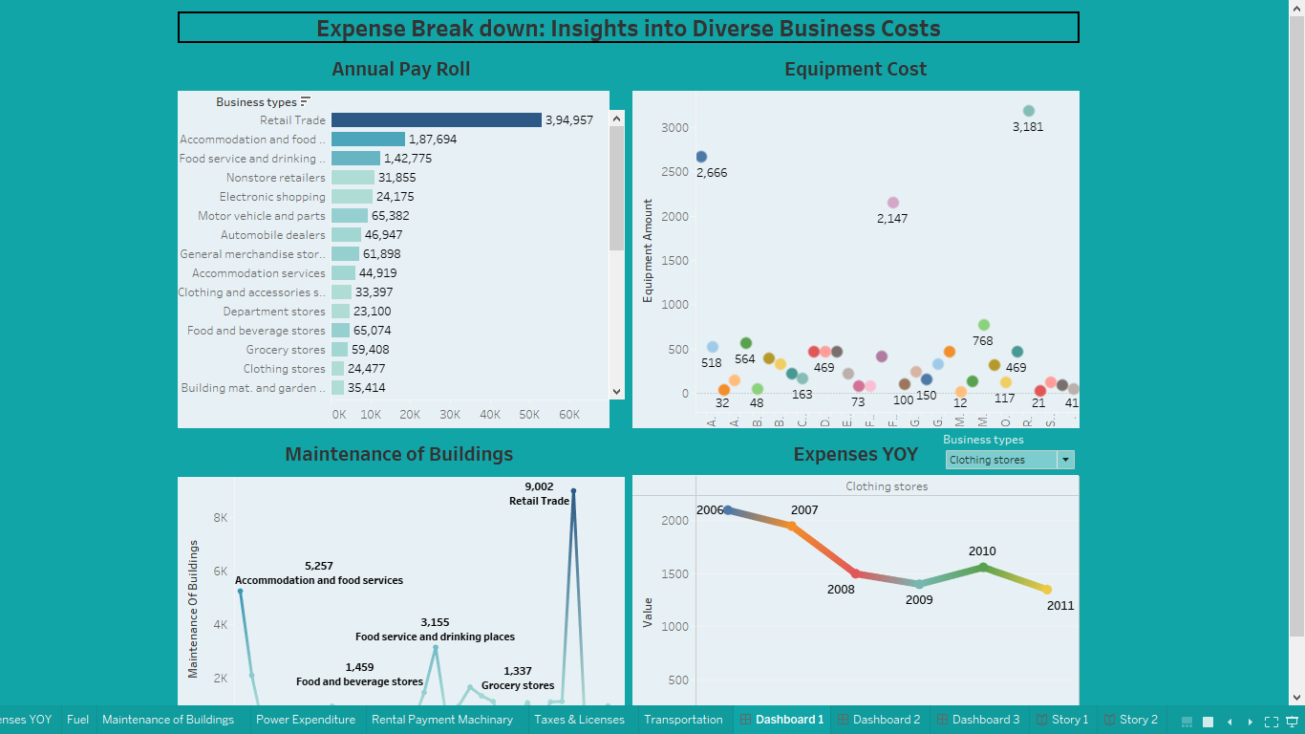

*Dashboard 2*

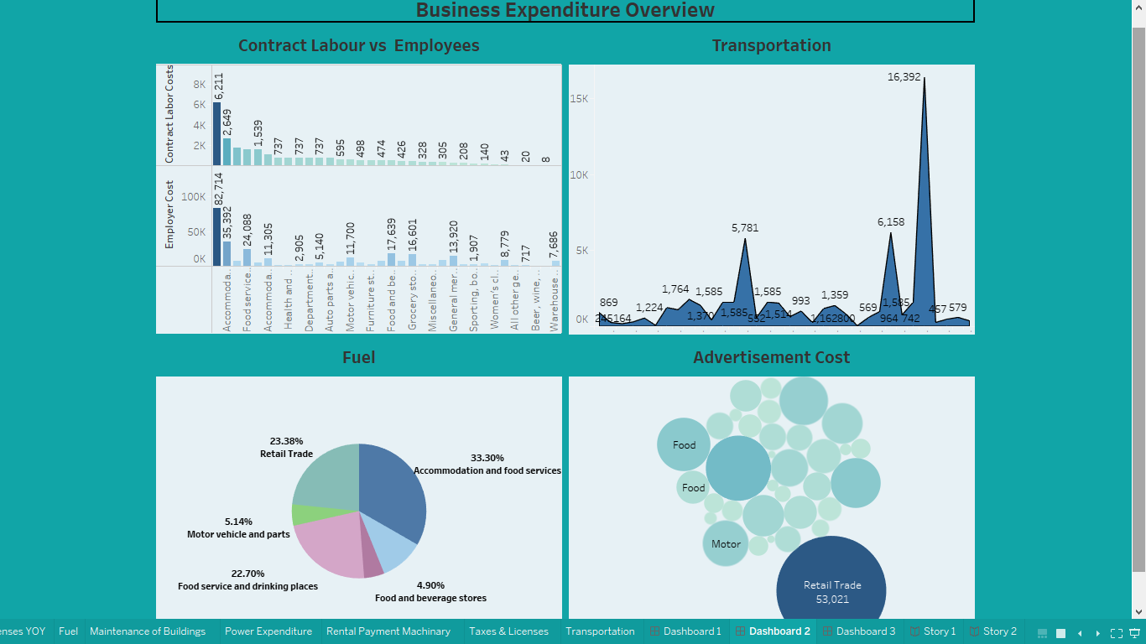

Dashboard 3

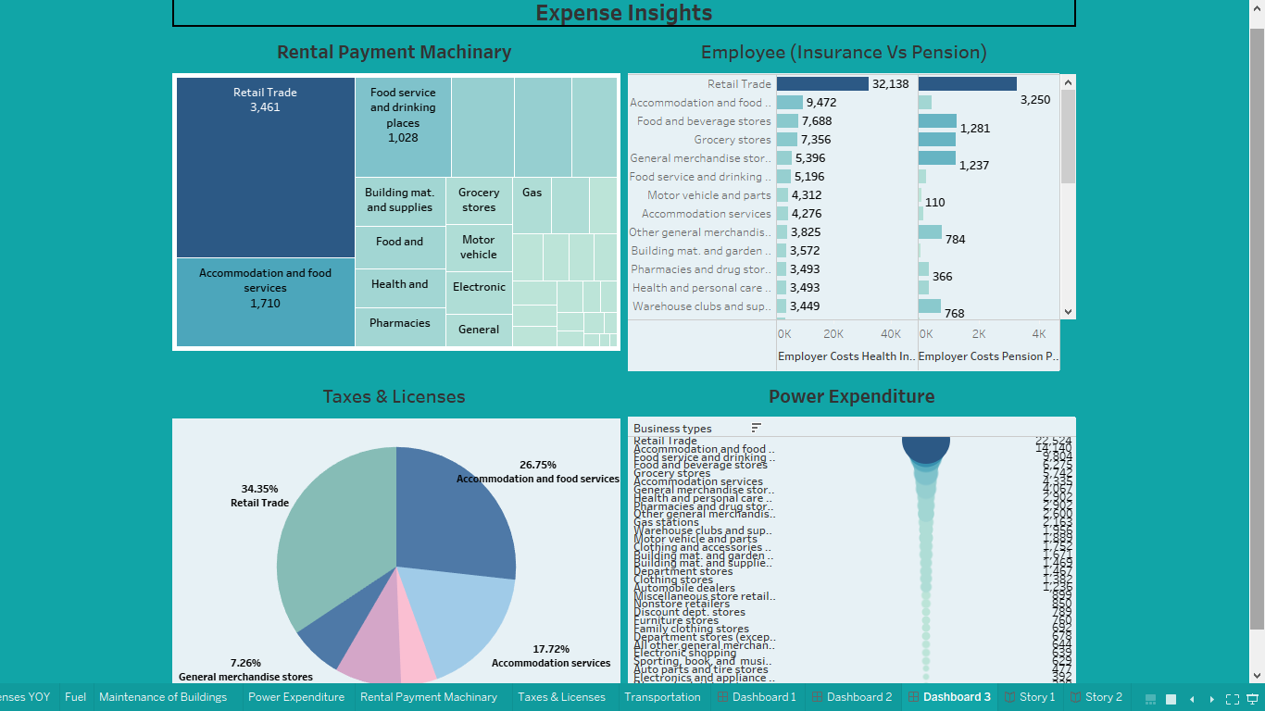

Story 1

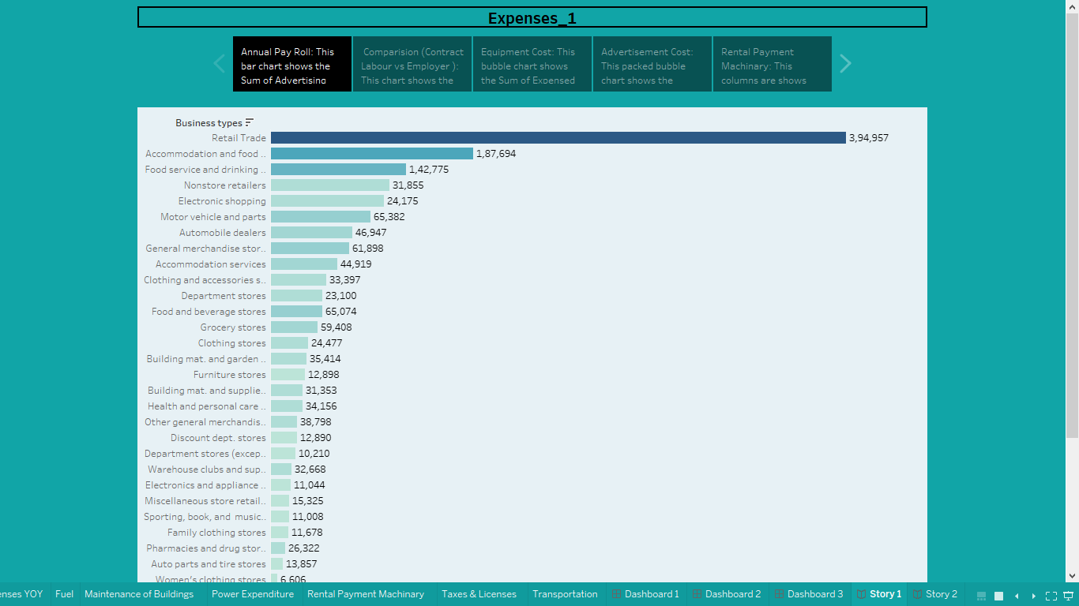

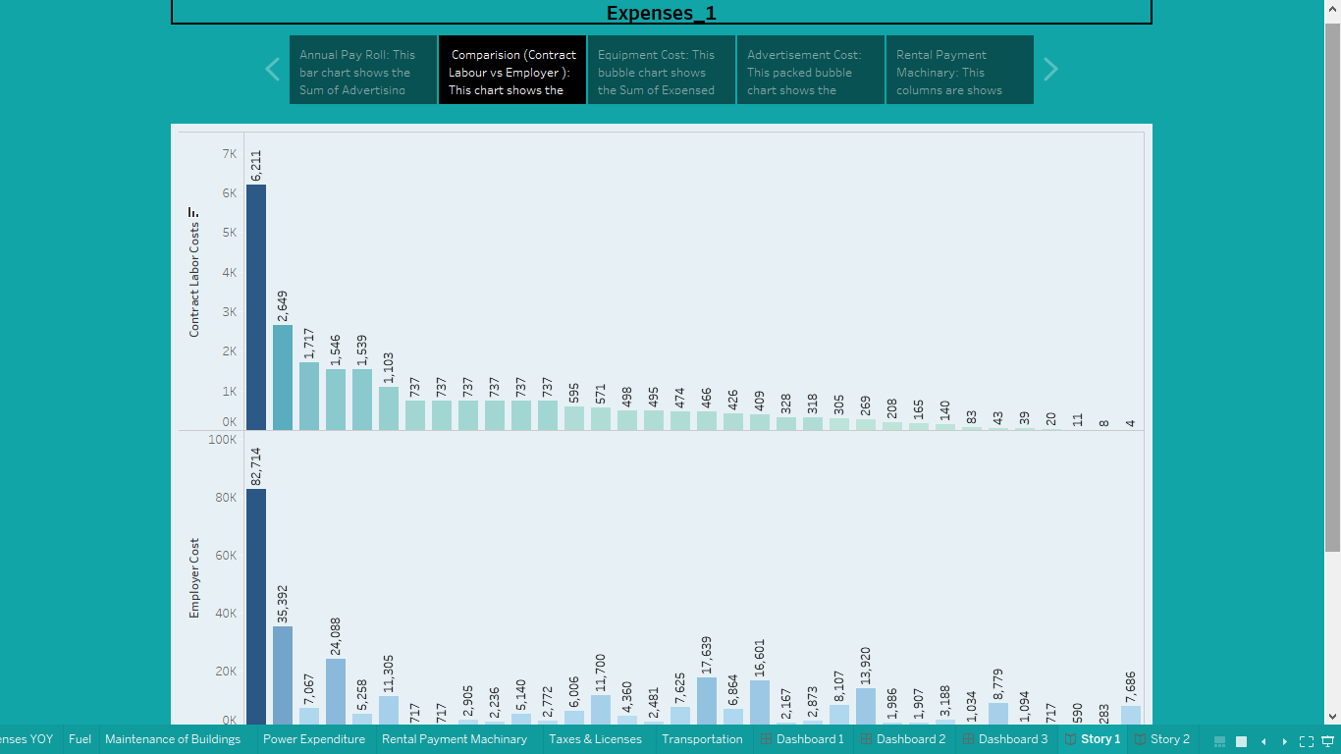

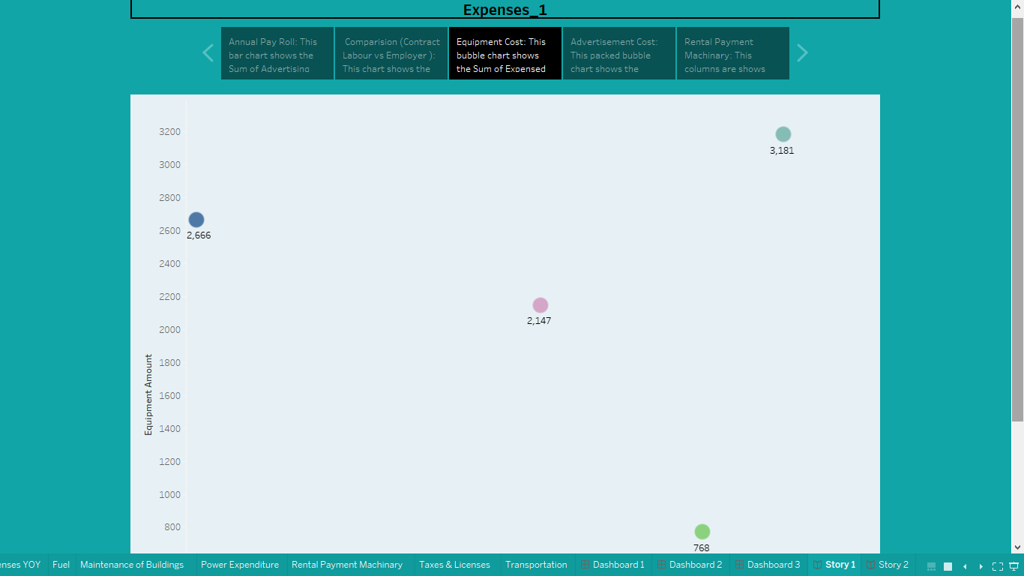

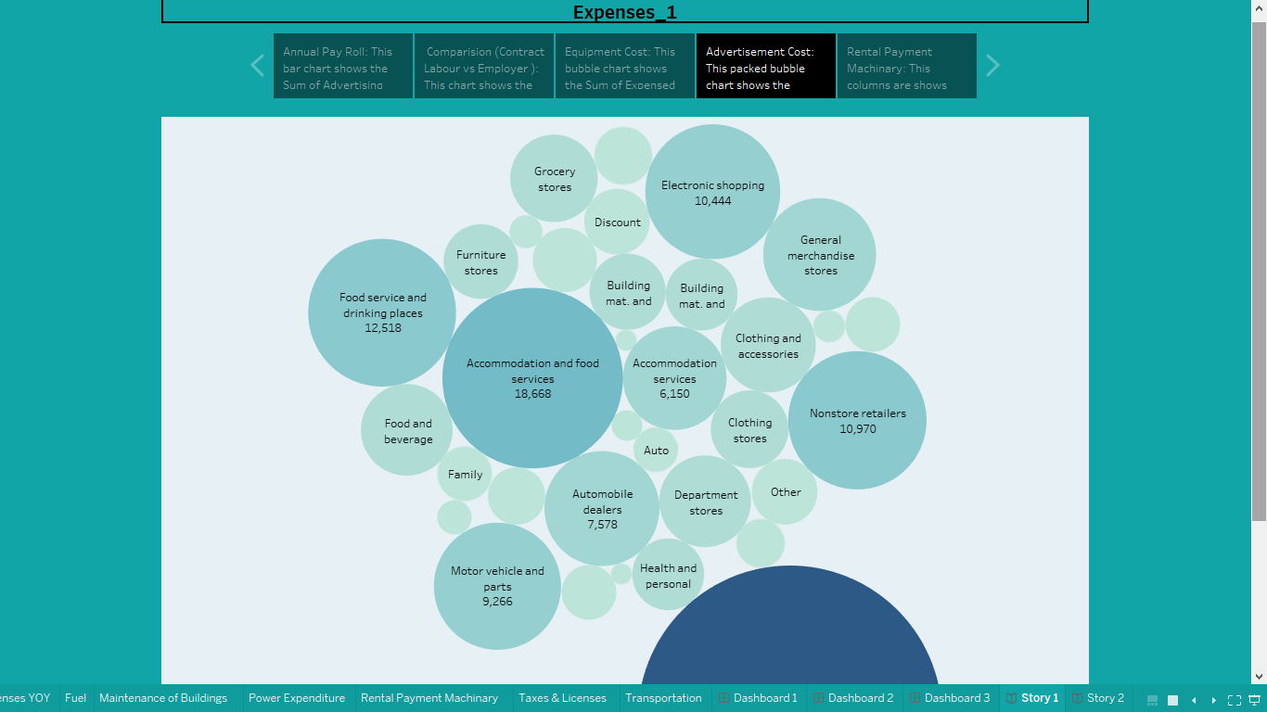

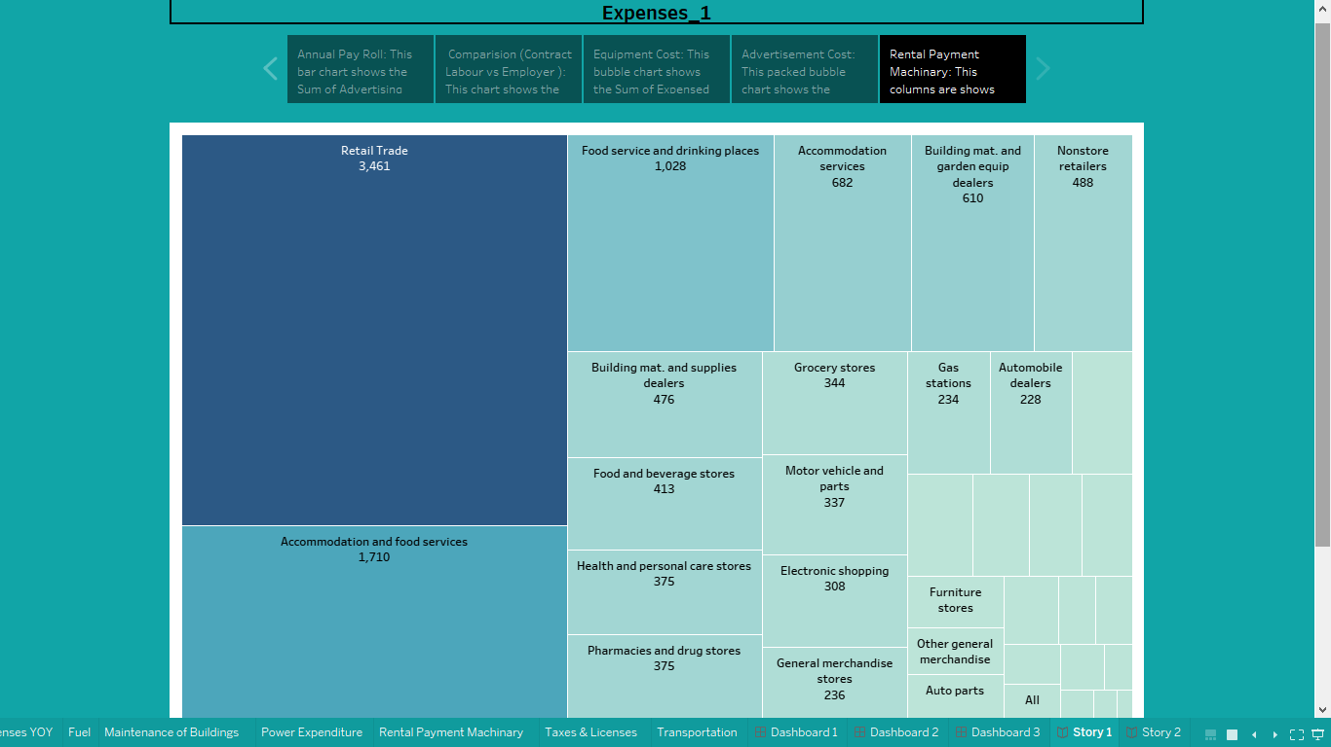

Story 2

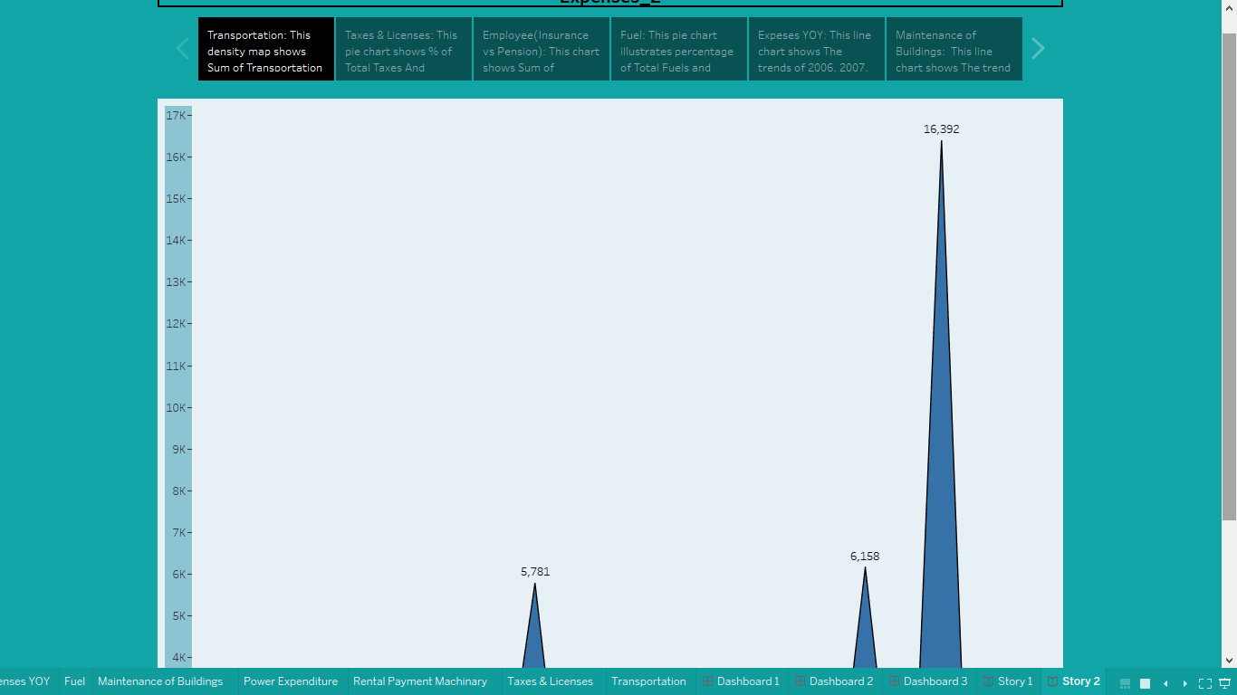

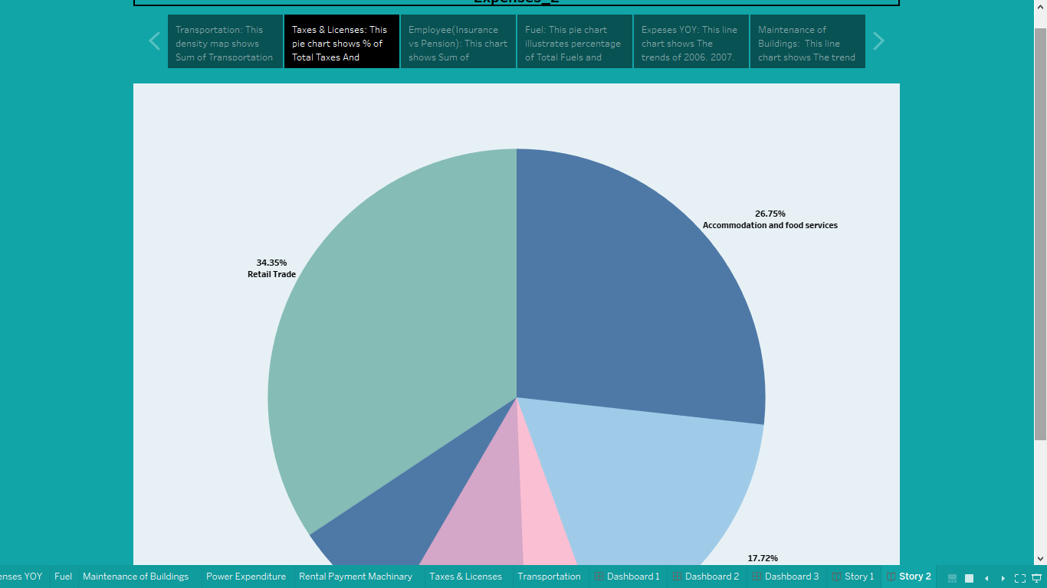

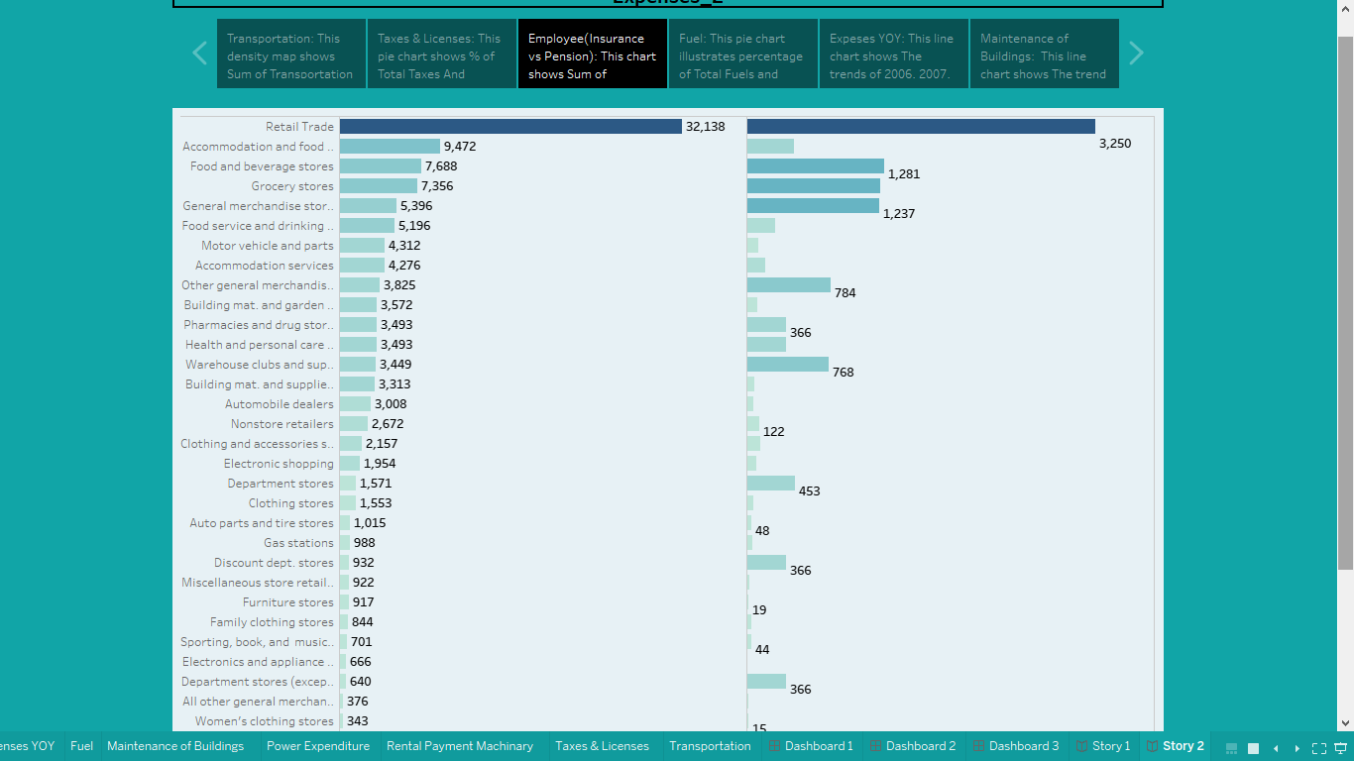

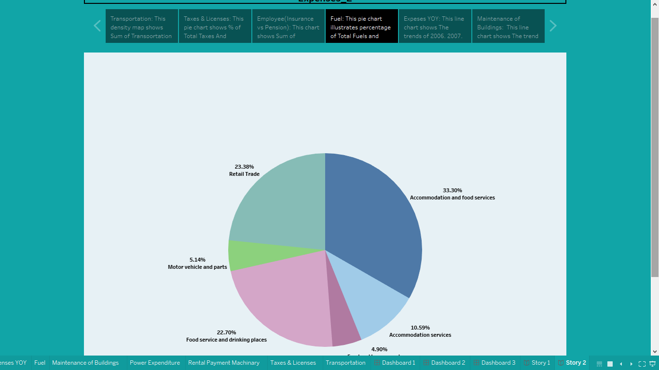

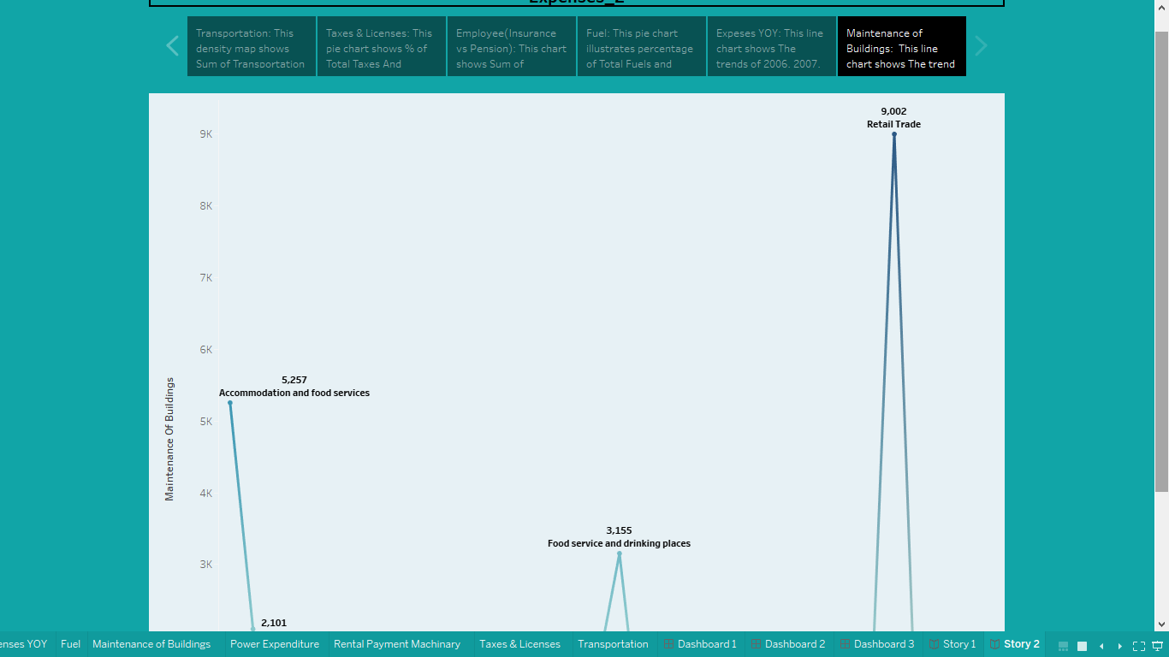

Advantages:

Some of the benefits associated with producing accurate cost estimates include: More accurate planning: When you’re able to accurately predict what tasks and resources are required to complete work, you’ll be able to efficiently produce a work breakdown schedule, assign work to staff, and adhere to projected timelines

Disadvantages:

The Business expenses records only indicate previous performance, but management makes long term decisions. Cost accounting incorporates costs at a specified pace. The prior year’s business estimation is not the same as current aren’t particularly useful.

Applications:

The areas business expenses solution can be applied in Advertising and marketing. Bank fees and interest, Business mileage, Commissions, Educational expenses for employees, Employee benefits, Equipment maintenance and repair, Furniture, etc.

Conclusion:

As we have seen, business expenses is a complex subject that reaches far beyond the individual budget of any given project. Different areas of the company use cost information in different ways, and the information must be formulated to suit the company area that it serves.

When project managers are planning a project, and in particular are creating a project budget, knowledge of the different kinds of costs that the project will incur is essential to successful budgeting. In addition, an understanding of overall cost at a particular company in a specific industry will help project managers create budgets that take cost into proper consideration and deliver winning results.

Future Scope:

Estimation of Business Expenses of quantities is the primary activity for any Construction or engineering job. The quantities established during initial stages determine your profitability at the end.

As a starter in estimation, you would be required to work under a contractor or manage a subcontractor. Initial scope may be not too promising, as many Diploma holders can easily do the estimation can help, when we elevate to the level of Construction manager. That is a position that really Pays.